**What You’ll Build**

* A **React** form for name, email, and password.
* A **Node.js server** that receives this data.
* Data is **inserted into a MySQL table** called users.

**Tech Stack**

* **Frontend**: React.js
* **Backend**: Node.js + Express
* **Database**: MySQL (local)

**Step-by-Step Implementation**

**CREATE DATABASE userDB;**

**USE userDB;**

**CREATE TABLE users (**

**id INT AUTO_INCREMENT PRIMARY KEY,**

**name VARCHAR(255),**

**email VARCHAR(255),**

**password VARCHAR(255)**

**);**

**2. Backend Setup (Node.js + Express + MySQL)**

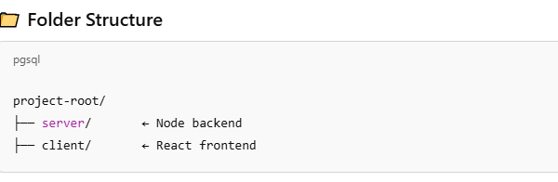

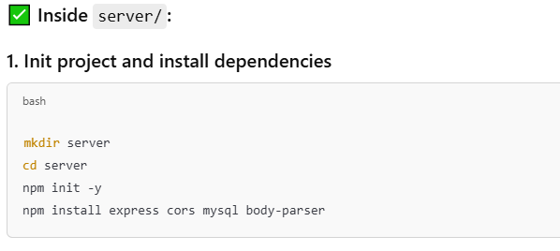

**2. Create server.js**

**// server/server.js**

**const express = require('express');**

**const cors = require('cors');**

**const mysql = require('mysql');**

**const bodyParser = require('body-parser');**

**const app = express();**

**const PORT = 5000;**

**// Middleware**

**app.use(cors());**

**app.use(bodyParser.json());**

**// Connect to MySQL**

**const db = mysql.createConnection({**

**host: 'localhost',**

**user: 'root',**

**password: '', // Use your MySQL password**

**database: 'userDB',**

**});**

**db.connect((err) => {**

**if (err) throw err;**

**console.log('Connected to MySQL');**

**});**

**// API endpoint to register user**

**app.post('/register', (req, res) => {**

**const { name, email, password } = req.body;**

**const sql = 'INSERT INTO users (name, email, password) VALUES (?, ?, ?)';**

**db.query(sql, [name, email, password], (err, result) => {**

**if (err) {**

**console.error(' Error inserting user:', err);**

**return res.status(500).json({ error: 'Database error' });**

**}**

**res.status(201).json({ message: 'User registered successfully' });**

**});**

**});**

**app.listen(PORT, () => {**

**console.log(`🚀 Server running at http://localhost:${PORT}`);**

**});**

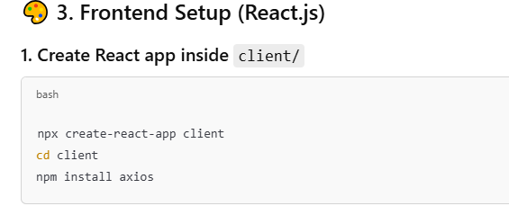

**2. Replace App.js with this:**

**// client/src/App.js**

**import React, { useState } from 'react';**

**import axios from 'axios';**

**function App() {**

**const [form, setForm] = useState({ name: '', email: '', password: '' });**

**const [message, setMessage] = useState('');**

**const handleChange = (e) => {**

**setForm({ ...form, [e.target.name]: e.target.value });**

**};**

**const handleSubmit = async (e) => {**

**e.preventDefault();**

**try {**

**const res = await axios.post('http://localhost:5000/register', form);**

**setMessage(res.data.message);**

**setForm({ name: '', email: '', password: '' });**

**} catch (error) {**

**setMessage('Registration failed');**

**}**

**};**

**return (**

**<div style={{ maxWidth: '400px', margin: '50px auto' }}>**

**<h2>Register</h2>**

**<form onSubmit={handleSubmit}>**

**<input name="name" placeholder="Name" value={form.name} onChange={handleChange} required /><br /><br />**

**<input name="email" type="email" placeholder="Email" value={form.email} onChange={handleChange} required /><br /><br />**

**<input name="password" type="password" placeholder="Password" value={form.password} onChange={handleChange} required /><br /><br />**

**<button type="submit">Register</button>**

**</form>**

**{message && <p>{message}</p>}**

**</div>**

**);**

**}**

**export default App;**

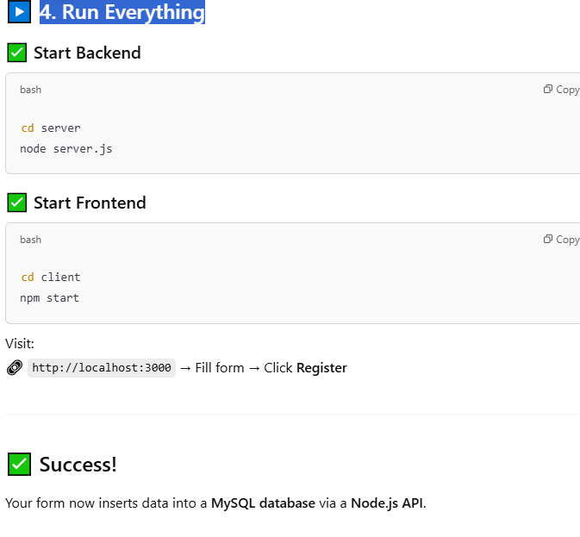

### Explanation: cors (Cross-Origin Resource Sharing)

* Allows your **React frontend (on port 3000)** to make HTTP requests to your **Node.js backend (on port 5000)**.
* Without this, your frontend would get a CORS error.

**Write the following command if you are not connect to the server in react.js**

